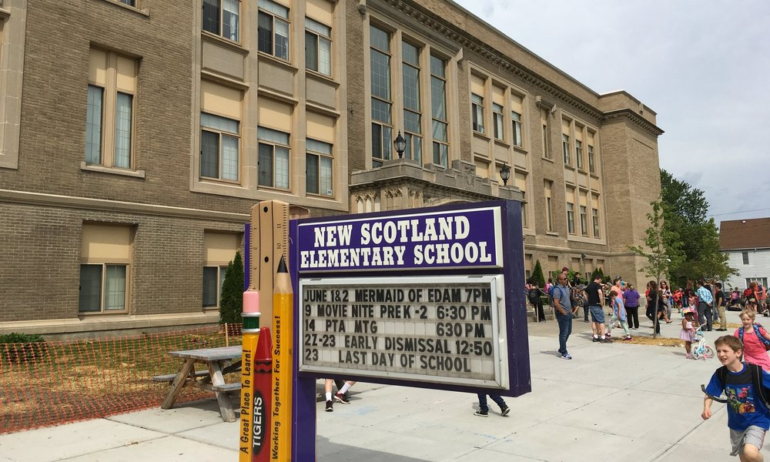

MINIMUM CAPACITY :-
The Minumum intake capacity
of students is between 300-420
children

LIBRARY :-
The Libarary is Available.

CANTEEN:-
The Canteen Facility is Available.

BOARDING :-
No availablility of boarding.

SPORTS :-
There are different categories
sports available.
Girls Volleyball
Boys Volleyball
Football

NEW SCOTLAND ELEMENTARY SCHOOL
ALBANY - SCHOOL

School Detail :-
New Scotland Elementary School is a public school located in Albany, NY, which is in a small city setting. The student population of New Scotland Elementary School is 450 and the school serves PK-5.
The district serves about 9,000 students in 15 schools: 11 elementary schools, three middle schools and Albany High School, a comprehensive high school with a career and technical education center. The district also offers additional innovative academic opportunities for students in support of our vision, mission and goals.

